Maze Solver Development Phase 2

Phase 2 Goals
The goal of phase two was to gain more familiarity with C++, refactor the code completed in phase one, gain exposure to and implement as many pathfinding algorithms as possible, specifically breadth first search, depth first search, A*, and Dijkstra’s Algorithm.
Phase 2 Tasks
Most planned tasks for phase 2 were accomplished. These tasks included:
- One of the main overall goals of the project is to learn the C++ programming language. As such, one of the main tasks in this phase was to research C++, focusing more on the modern aspects introduced in the C++11 and C++14 standards. This task was completed mainly by reading the book C++ Primer by Stanley Lippman and the online C++ reference.

- Refactor the code completed in phase one – While all the goals of phase one were successfully accomplished, the code was written so as to be functional, without concern for readability, organization, or future features to be implemented. As a result, one of the major goals of this phase was to refactor and abstract the code using proper object orientation principles. The classes created are intended to be as generic as possible to practice keeping reusability in mind when writing a program. For example, ideally, one could take the Maze class and use it in another program with little hassle. Admittedly, there are still issues with the reusability of this code and full reuse potential may not be achieved, but this is something that will continue to be worked on throughout the rest of development so as to gain more practice.

- In reference to the previous task, as opposed to having all the code in the file main.cpp, several classes were created and the code was reorganized into several class and header files. Specifically, Maze.cpp, Cell.cpp, Quad.cpp, Text.cpp, and the respective header files for each of these classes. This reorganization made the program much easier to modify, as opposed to the unorganized version completed in phase one.

- Learning various pathfinding algorithms – The goal was to gain exposure to several pathfinding algorithms, specifically depth-first search (DFS), breadth-first search (BFS), Dijkstra’s algorithm, and A* search. Of these, DFS, BFS, and Dijkstra’s algorithm were learned. Due to time constraints, A* was ultimately scrapped.

- Implement the pathfinding algorithms:

  - Breadth-first search – While a fairly easy algorithm to understand, the implementation turned out to be more difficult than expected.. This was not due to a problem with comprehending the algorithm, but due to a lack of adequate understanding of the C++ language. Once references and pointers were studied thoroughly, implementation became simple. A traditional breadth-first search does not return the shortest path, but this path can be found by forming a tree of nodes that are searched and tracing the parents of each node beginning with the goal.

b. Dijkstra’s algorithm – This was the next algorithm learned. Though the algorithm was studied and understood somewhat well, it was not succesfully implemented. It will continue to be worked on, but was abandoned temporarily so as to progress with depth-first search.

c. Depth-first search – The last algorithm implemented was the simplest to implement. Following the successful implementation of breadth-first search, its depth-first counterpart did not present much problem. The path, while not guaranteed to be the shortest path, was determined using the same method as with the breadth-first search.

- Following the code refactoring, the maze can now easily be adjusted to accommodate many more cells compared to the phase one version of the program, resulting in a much larger maze.
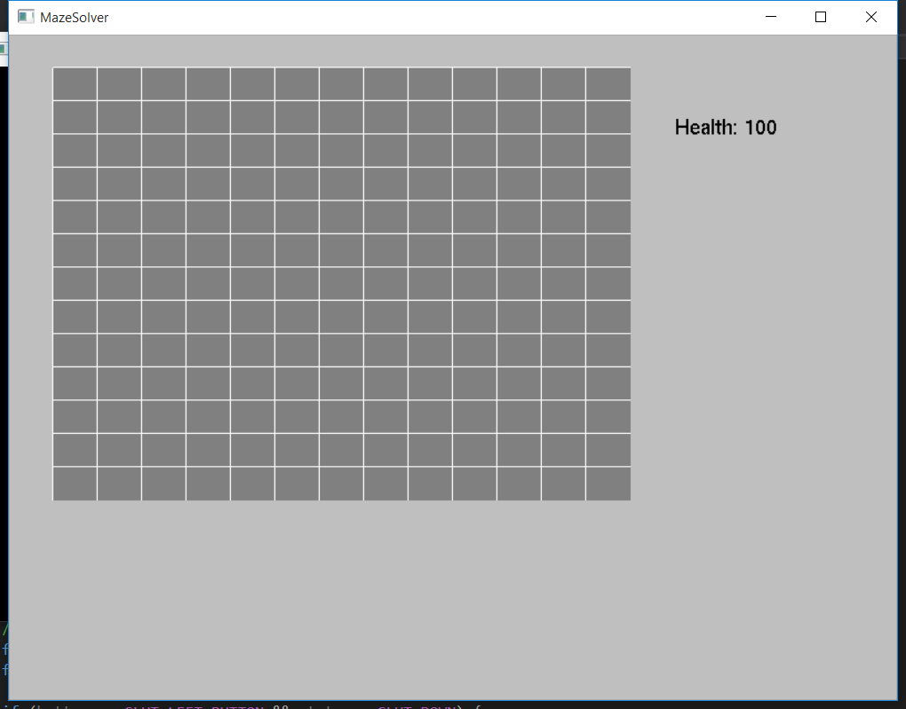
Phase one’s maze

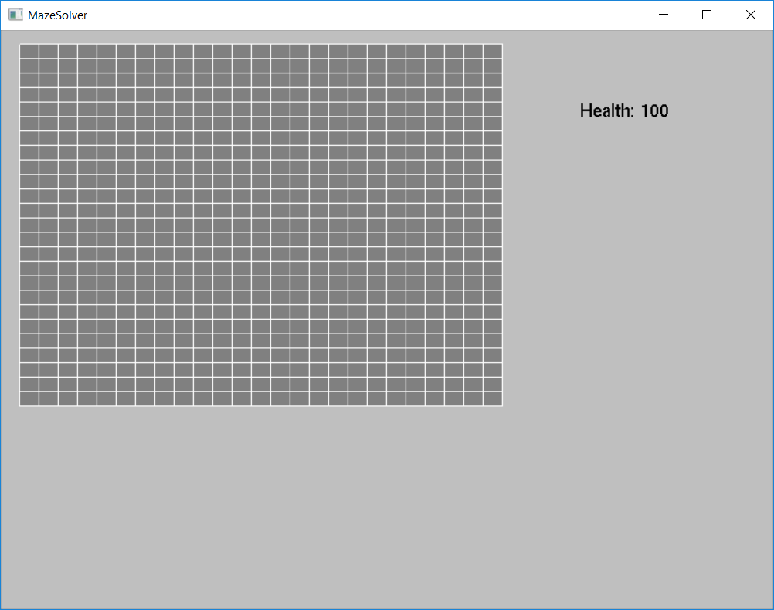

Phase two’s maze
Concepts Learned
Many aspects of C++ were introduced in this phase. Though much was not necessary for use in the program itself, research was done merely to gain more exposure to the language, as one of the main goals is to learn as much C++ as possible. More of the Standard Template Library was experimented with, such as the List template, which is effectively a doubly linked list. Stacks, queues, and priority queues were used as well, for the various algorithms implemented. The use of references was also a new concept, and while pointers were already known prior to learning C++, skilled use of them had to be refined. Polymorphism in C++ was learned as well, with the use of the virtual keyword.
In addition to this, exposure to and an understanding of previously unknown graph searching algorithms was gained, specifically breadth-first search, depth-first search, and Dijkstra’s algorithm.
Phase 2 Plans
Phase 2 will include heavy research into artificial intelligence algorithms as well as the implementation of more basic maze solving algorithms. Some of these algorithms will potentially include A*, breadth first search, greedy algorithms, and shortest path algorithms. Resources have been compiled including online tutorials as well as introductory books for researching these concepts.
Another goal of phase 2 will be to refactor some of the code, such as abstracting certain tasks, and generally cleaning up some of the existing code, such as changing certain routines to be more efficient.
Phase 2 marks the beginning of completely uncharted territory. With a small background in computer graphics, the tasks to complete phase 1 were not entirely new to us. The next phase, however, will be composed of mostly unfamiliar concepts, and as such will be comprised of heavy amounts of research and experimentation. We are looking forward to it.

